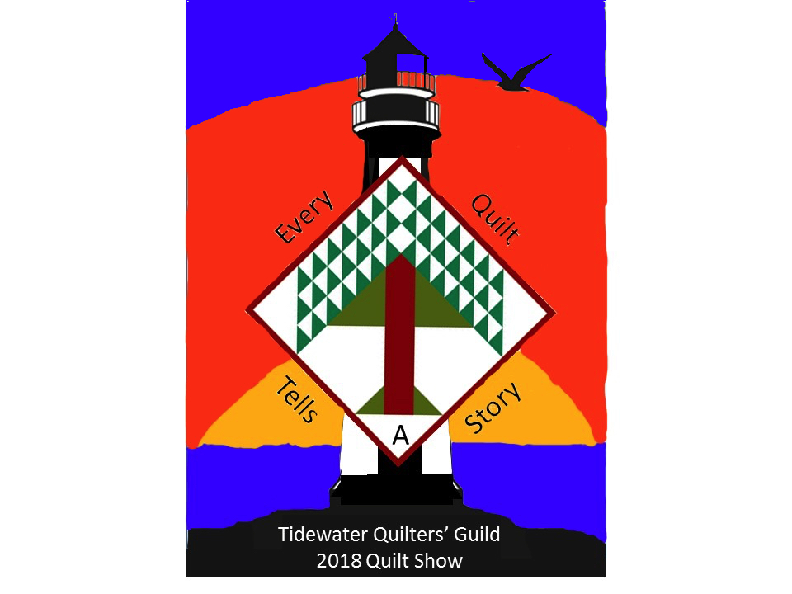

Tidewater Quilters’ Guild 2018 Quilt Show

Sara Madson’s Dazzling Diamonds Workshop
Saturday August 18, 2018
10:00 am – 4:00 pm
Cape Henry Collegiate School
Mill Dam Rd,
Virginia Beach, 23454

Cost: $50 (includes multiple day entry to the Quilt Show)
All checks will be cashed when a seat in the class is assigned.

Class kit $35.00 including all materials necessary is required and will be available from the teacher on the day.

Send Checks Payable to TQG, Inc. to:
Debby Coleman, 1520 Stephens Rd, Virginia Beach, VA 23454
For more info, contact Debby at (757) 434-5117 or carlndebbycoleman@gmail.com
---------------------------------------------------------------------------------------------------------------------

Dazzling Diamonds Workshop

Workshop Registration

Name : ____________________________________________
E-mail : ___________________________________________ Tel : __________________
Address : ___________________________________________________________________

