TIDEWATER QUILTERS’ GUILD WORKSHOP

“ABSTRACT-a-licious”
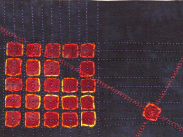
Saturday, March 11, 2017
9:30 am – 4:00 pm
Wycliffe Presbyterian Church
1445 N Great Neck Rd.
Virginia Beach, VA 23454

Cost $30 - TQG Members; $35 - Non-Members
TQG Members will have first-priority until February 15. Non-members may submit registration forms at any time and they will be processed beginning February 16, 2016.
All checks will be cashed when a seat in the class is assigned.

Send Checks Payable to TQG, Inc. to:
Pat Carney, 1796 Greensward Quay, Virginia Beach, VA 23454
For more info, contact Pat at (757) 270-3705 or carneypl@yahoo.com
-------------------------------------------------------------------------------------------------------------------------------

“ABSTRACT-a-licious”
Workshop Registration

Name _________________________________________TQG Member #_______

EMAIL______________________________________Phone__________________

Address____________________________________________________________

There will be no potluck. Please bring your lunch.

